**Exhaustive Analysis of Indian Agriculture using Power BI**

**WEEK-1**

**BI** means Business Intelligence.

**POWER BI** is a business intelligence tool

It is provided by Microsoft for analysing and visualizing raw data to present actionable information.

**ETL**

EXTRACT – Pull data from data source: excel, file, csv, text

TRANSFORM – Data processing, cleaning

LOAD – For analysis

**STEPS IN WORKING WITH POWER BI**

1. First we have to **download** Power BI latest version from Microsoft site.

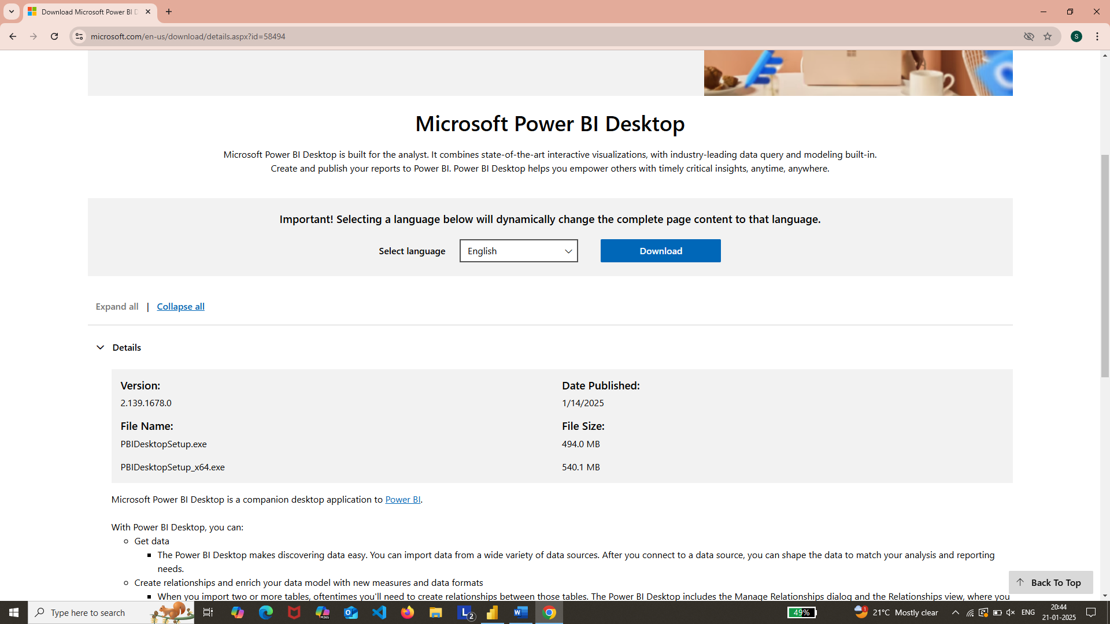

1. After downloading, we have to **install.**
2. Next we have to open Power BI. Page is as below one.

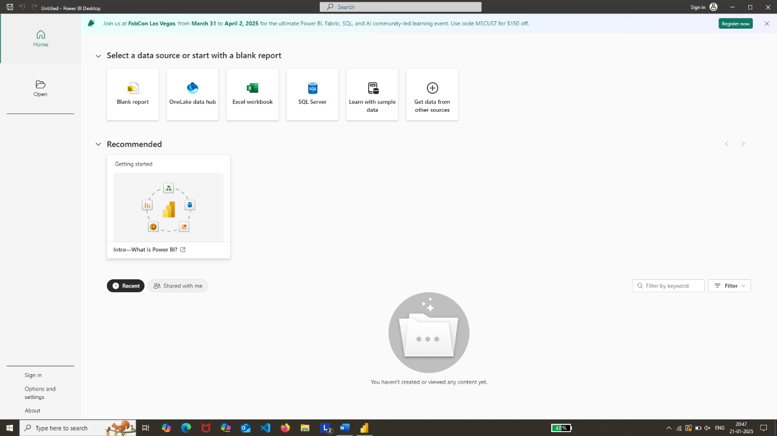

1. Next we have to click on **Blank report** option.

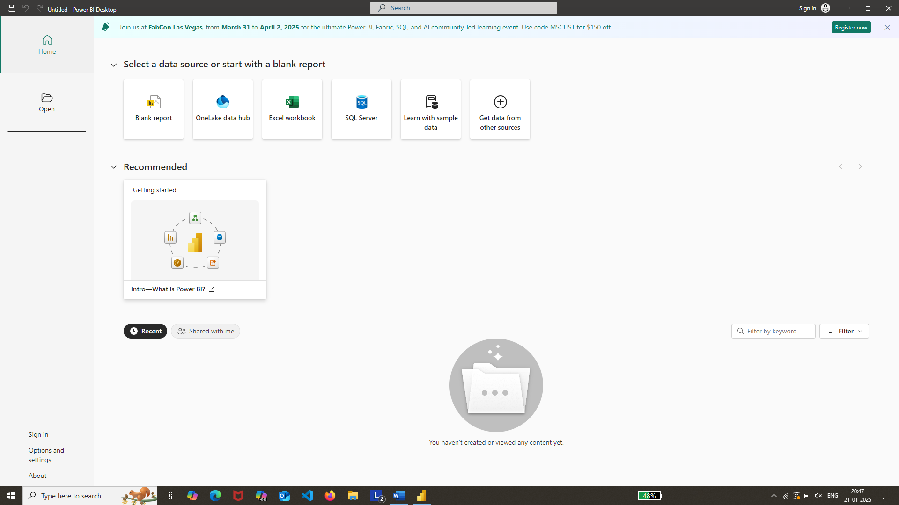

1. After that we have to select **get data** option then a dropdown box gets opened.
2. In that there is a option called **Text/CSV**. We have to click it.

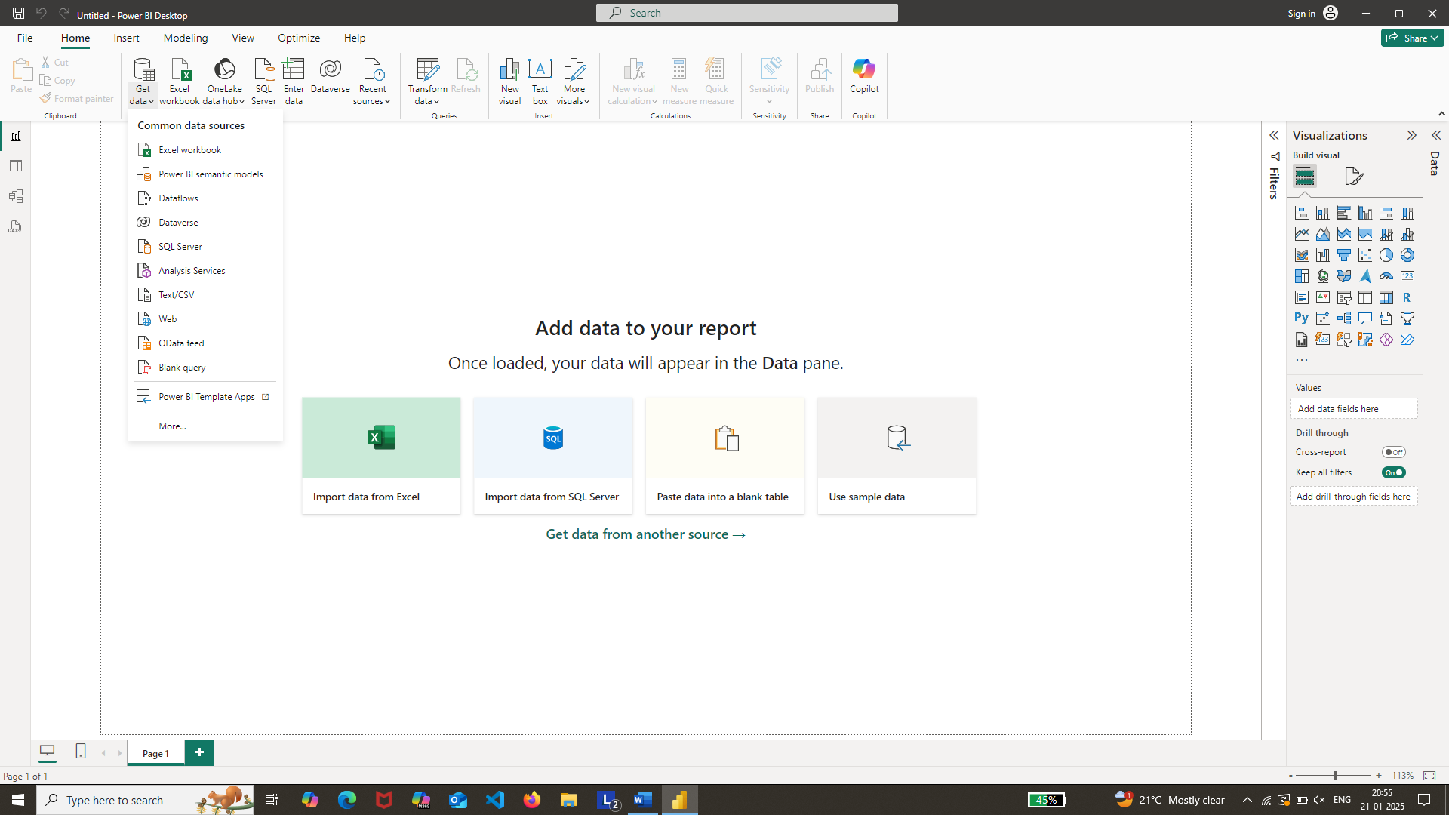

1. Next we have to select our dataset

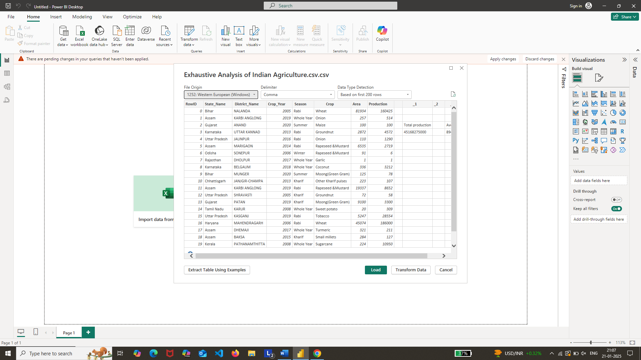

1. After selecting our dataset comes here. Here we have two options called **load** and **Transform data**

Load – we have to load the data when dataset is clean.

Transform Data – we have to use this when data is to be processed.

1. We have to work on the data processing and perform data cleaning and remove noise data.
2. For performing above processes, we have to click **transform data** option.
3. After that, another page **“Power Query Editor**“ opens where the dataset transformation occurs.

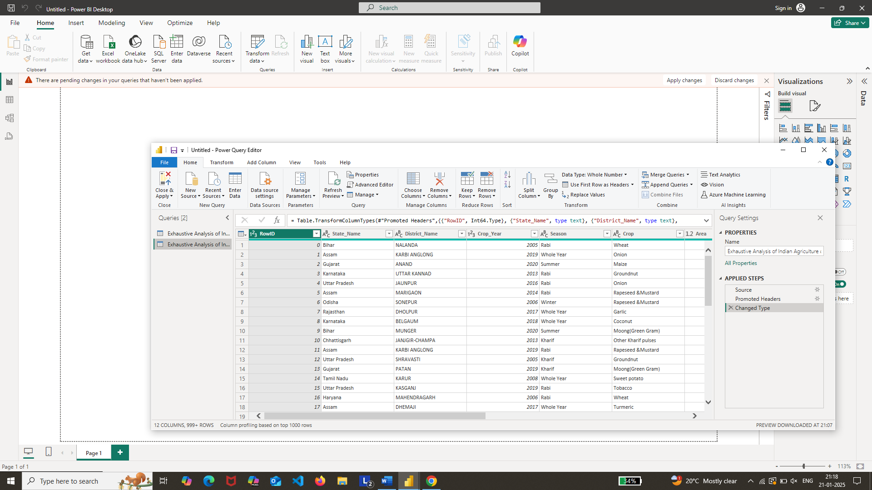

1. Now in our dataset, there is no use of **RowID** column. So we have to delete it. For deleting, we need to right click on the column name and click on **remove** option. It gets deleted.

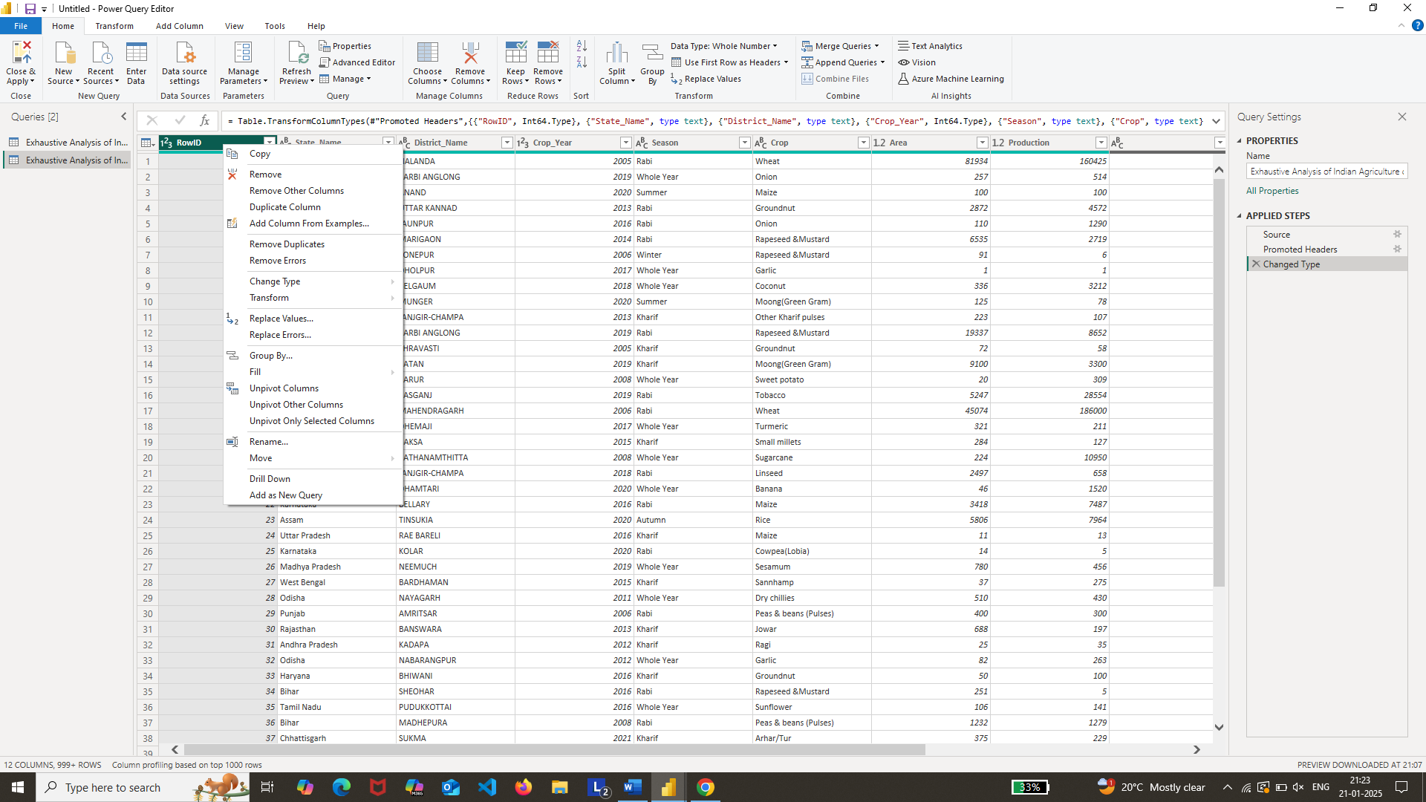

1. In the same way , there are empty columns at the end. We have to delete in the same way.

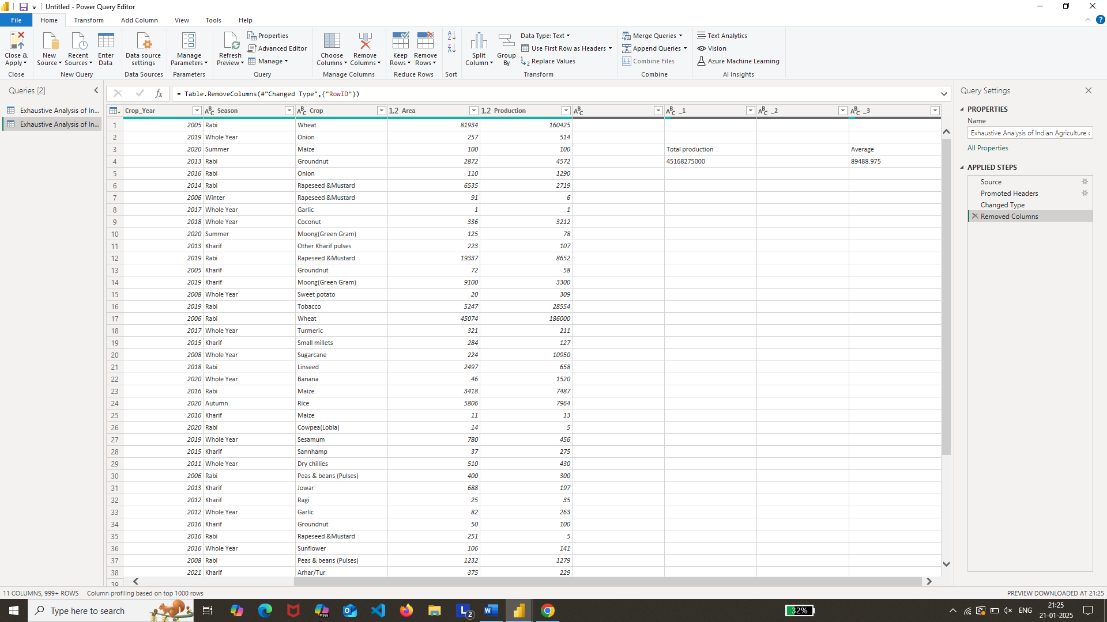

1. Next we have to click view option in that check for **column quality** option. Quality of our dataset is shown.

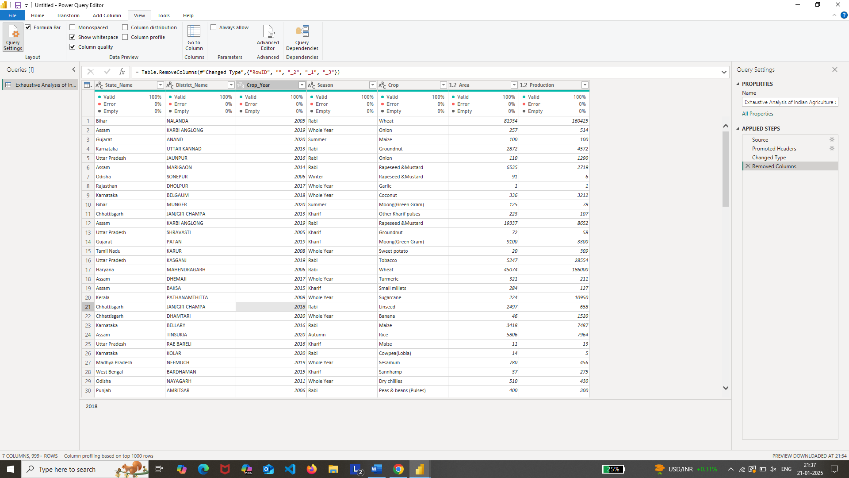

1. As valid is 100% for every column, we no need to perform any other operations on the dataset and can load the dataset as it is ready.
2. For loading dataset, we need to click on the **Close & Apply** option. It gets loaded.



1. For checking the dataset, we can click on **table mode** option. Our transformed data gets opened.

